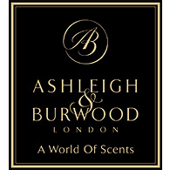

PRESS RELEASE
Introducing Fragrance Lamps
The beautiful scent diffuser that purifies the air in your home

Ashleigh & Burwood - The Scent Experts, have been creating exquisite ways to set the perfect mood and ambience with fragrance for over 25 years. Their Fragrance Lamps are an innovative and elegant way to introduce a world of scents to the home, infusing interiors with fragrance while purifying at the same time.
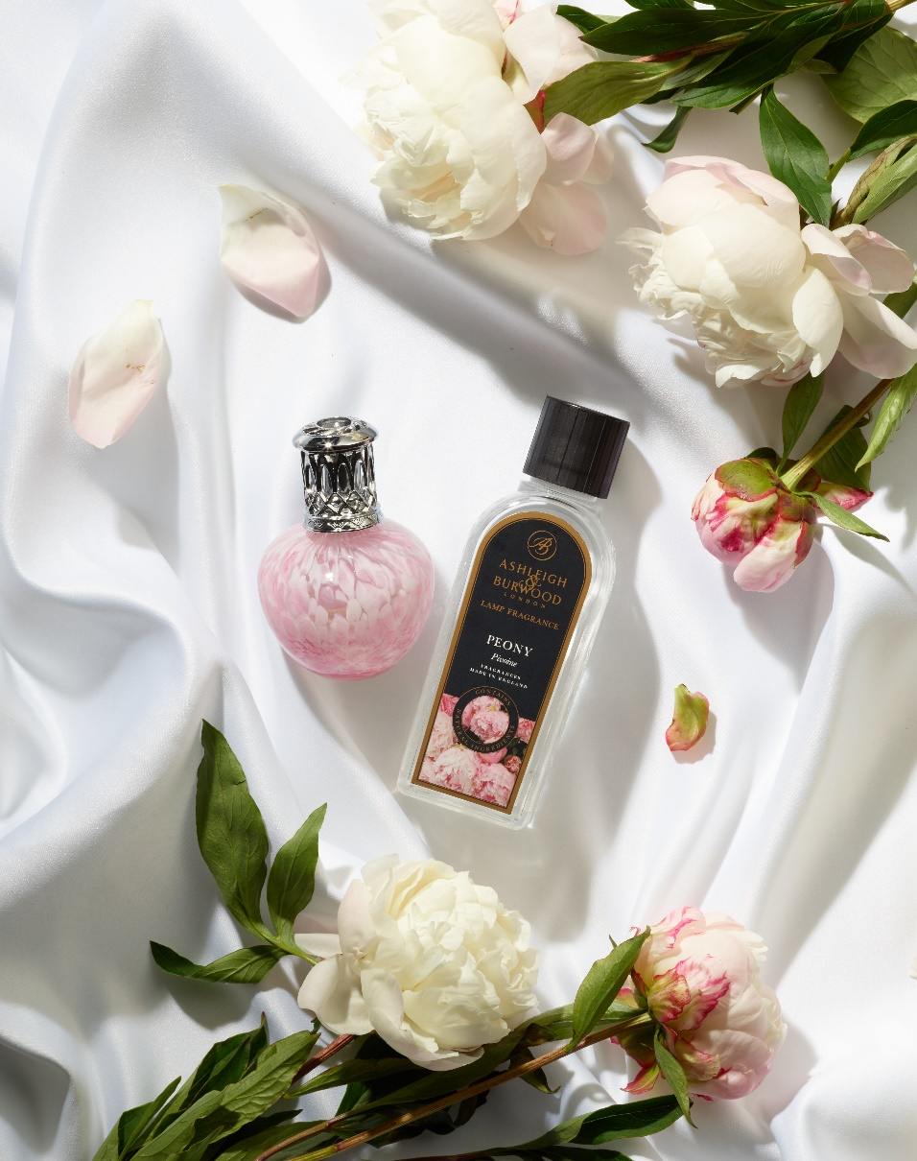
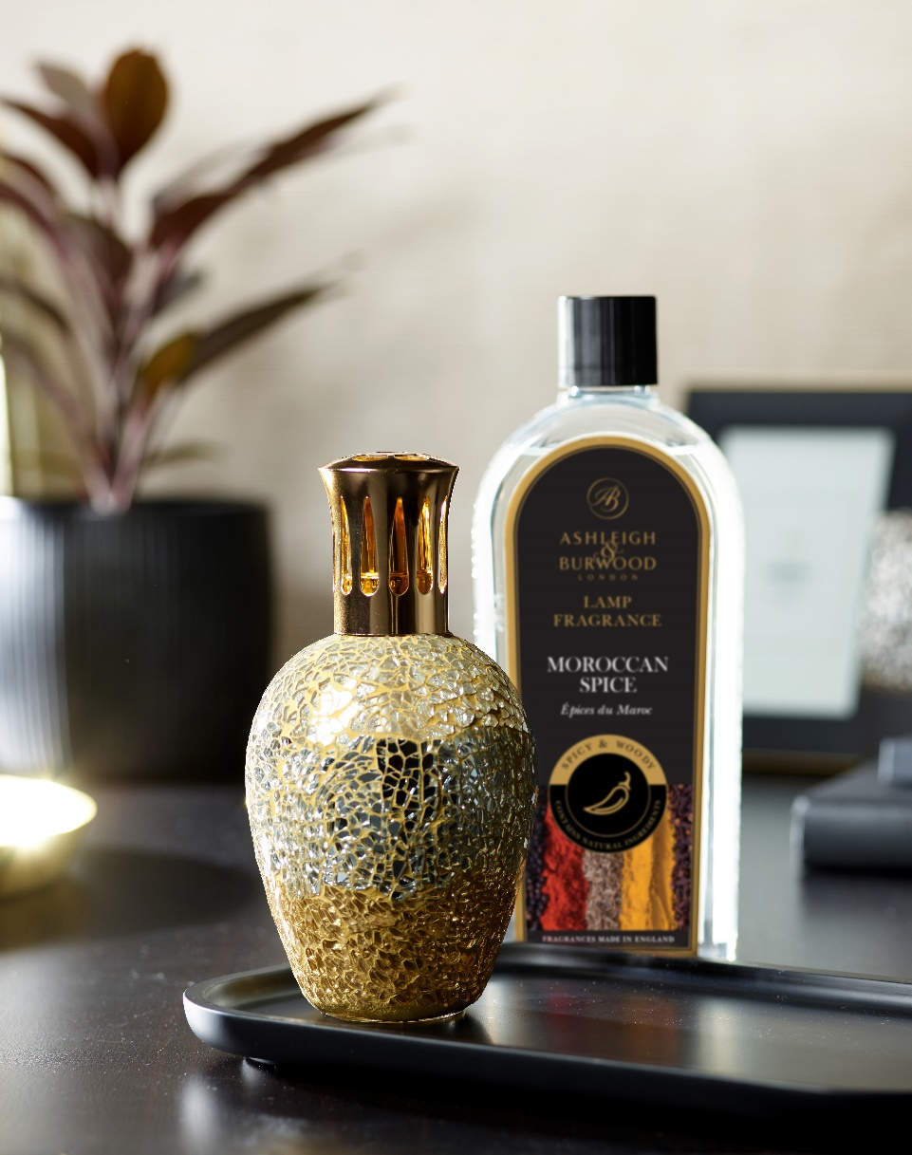
Available in a choice of shimmering hand-crafted mosaic and beautifully elegant glass designs, each vessel looks stunning on display. In addition to their stylish appearance, Fragrance Lamps diffuse fragrance quickly and effectively, transforming the air, scent and atmosphere in an average-sized room (16m²) in around 30 minutes.

Fragrance Lamps are a safe home-fragrancing method, requiring only two minutes of flame to start a catalytic reaction. This releases both oxygen and negatively charged ions into the air, purifying the air whilst adding ambient fragrance.

With fragrances inspired by landscapes near and far to evoke a journey through a world of scents, there are over 60 Lamp Fragrance options to choose from. Favourites include exotic Moroccan Spice, clean Fresh Linen, elegant Peony and zesty Sicilian Lemon. Each fragrance is blended using natural extracts and made in the UK.

Fragrance Lamp Gift Sets - £39.50
Fragrance Lamp – from £30
Lamp Fragrance – from £9.50

www.ashleigh-burwood.co.uk
blog.ashleigh-burwood.co.uk

FOR MEDIA ENQUIRIES, PRODUCT SAMPLES, PHOTOGRAPHY & INTERVIEW PLEASE CONTACT THE SCENT EXPERTS:
PR Manager: Deborah Bettinson
Email: deborahbettinson@ashleigh-burwood.co.uk
Tel: + 44 (0) 1932 267060

